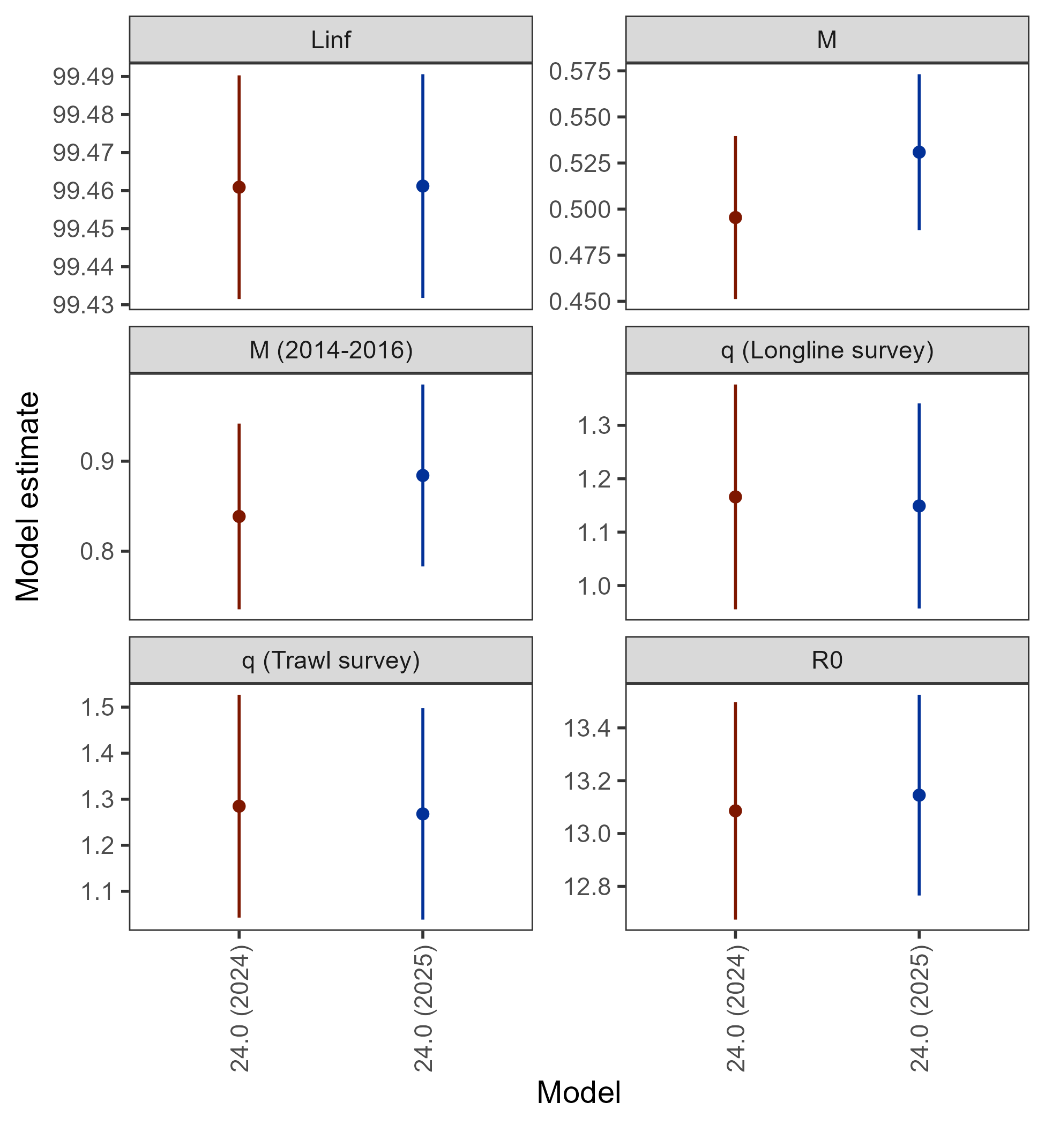

Figure 2.S1. Comparison of key parameter estimates with 95% confidence intervals from Model 24.0 as applied in 2025 and updated in 2026.

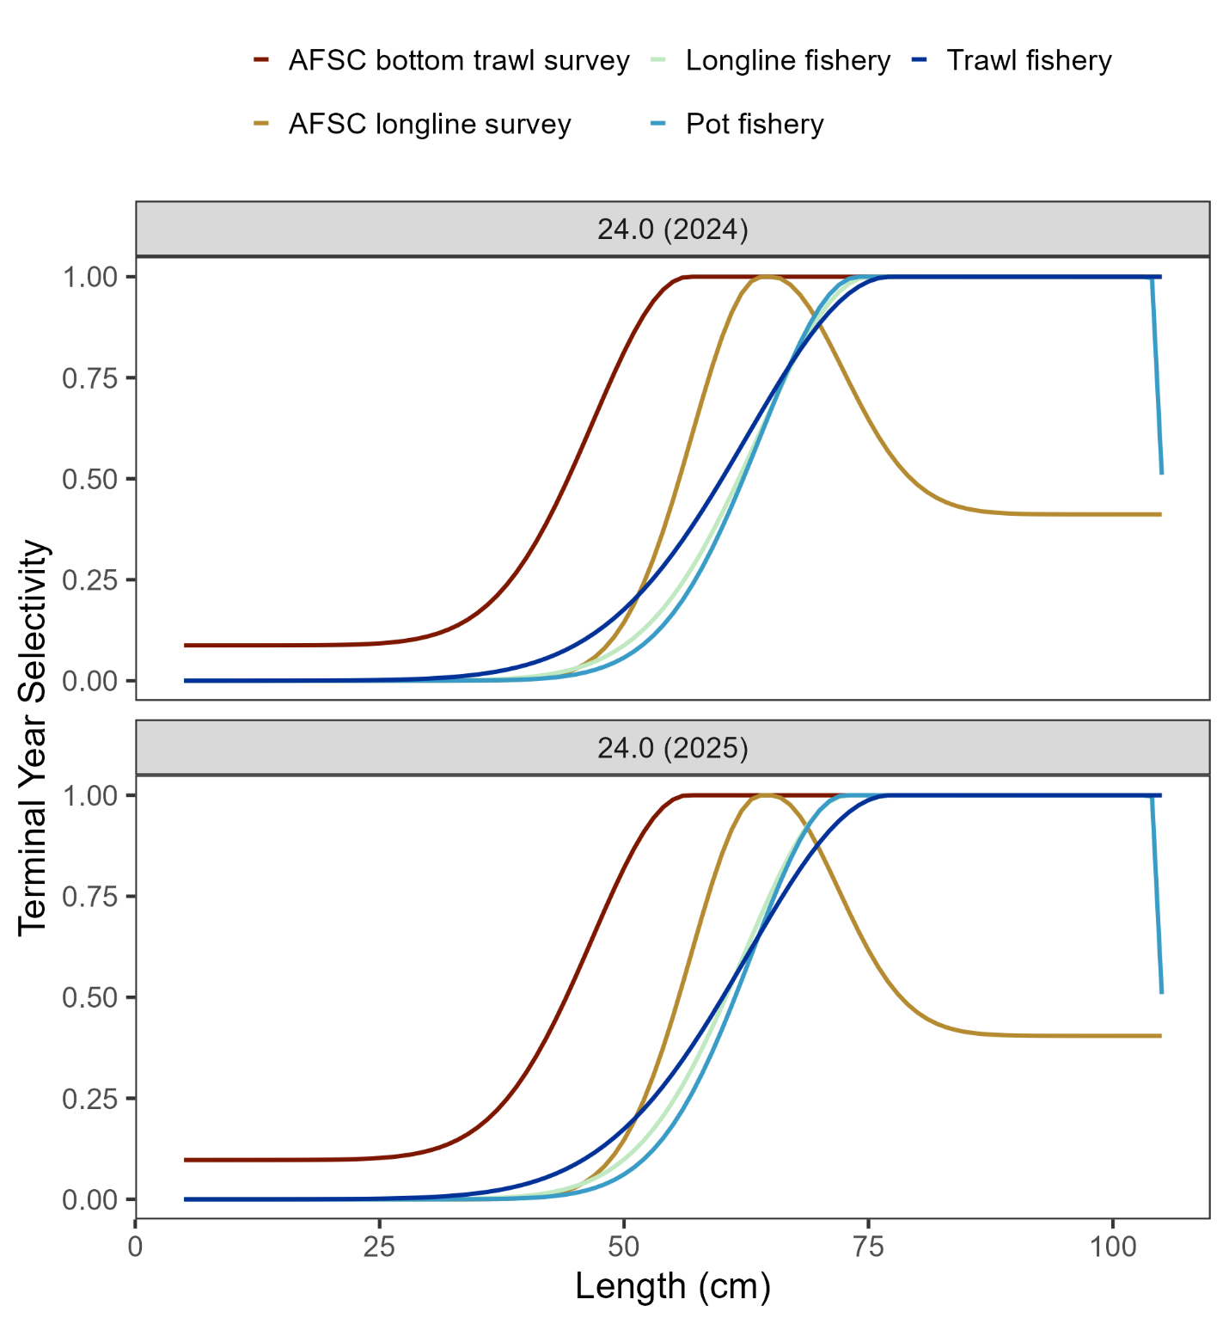

Figure 2.S2. Comparison of current year selectivity from Model 24.0 as applied in 2025 and updated in 2026.

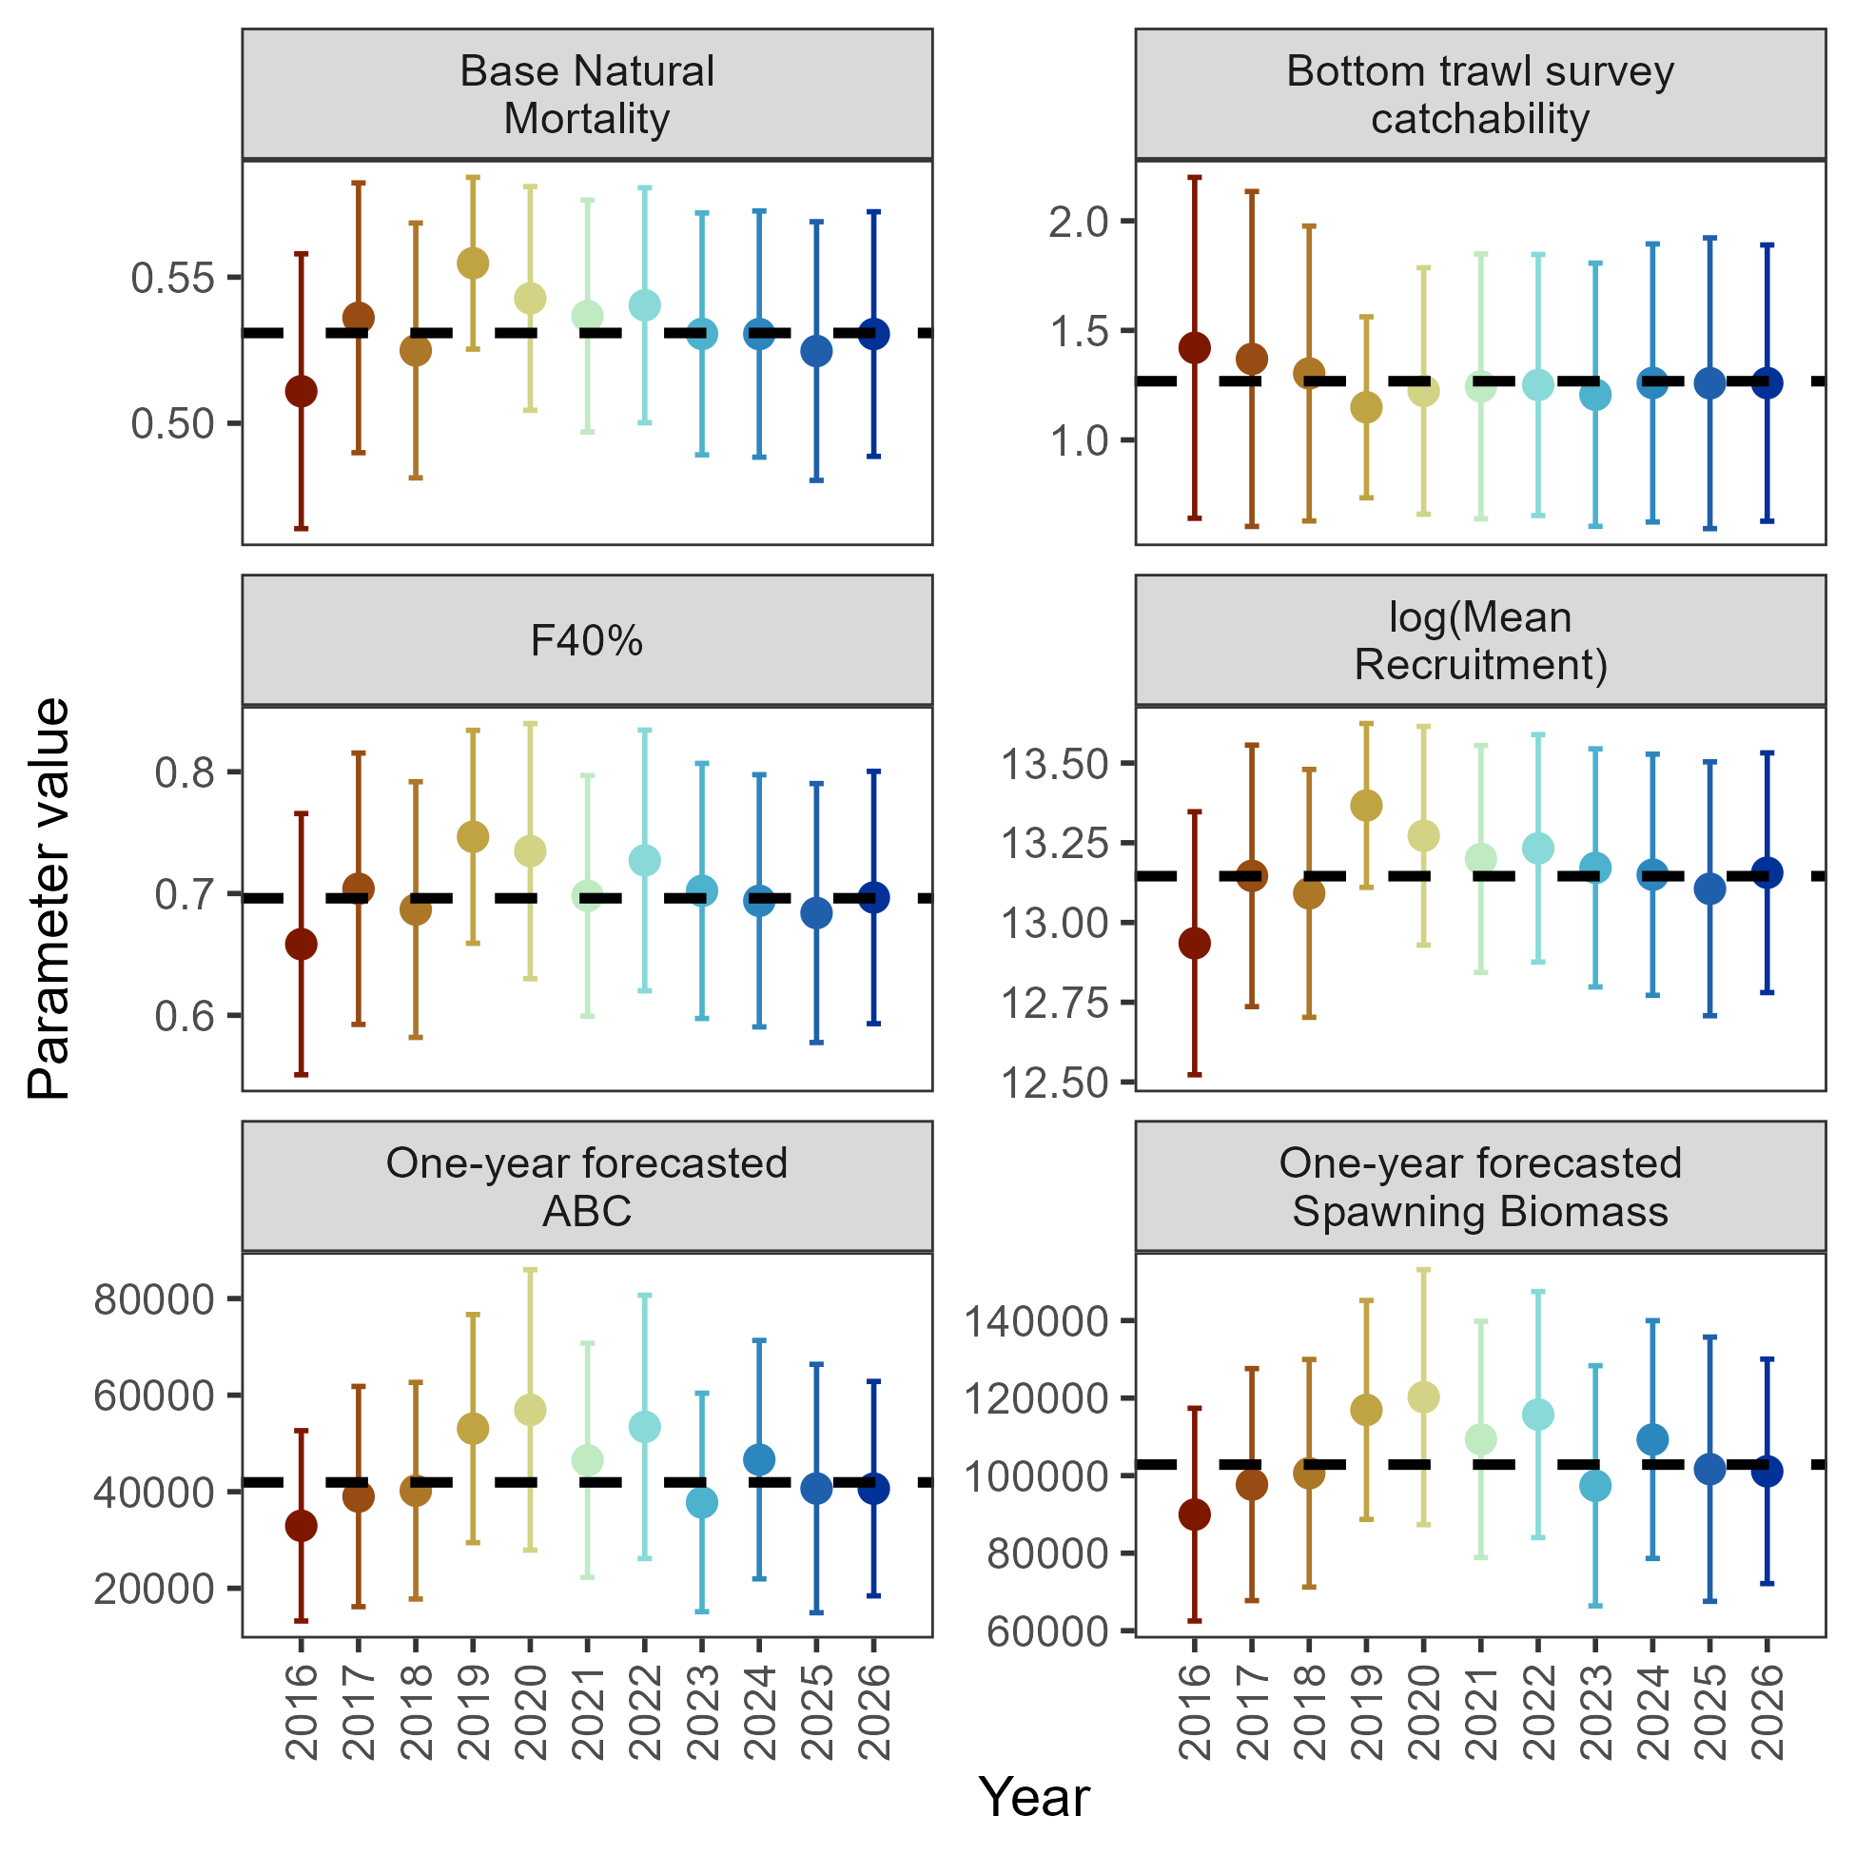

Figure 2.S3. Leave-one-out analysis showing parameters and derived quantities as one year of data were removed from the model fit of Model 24.0. The horizontal dashed line denotes the estimate from Model 24.0 with updated data through 2026.

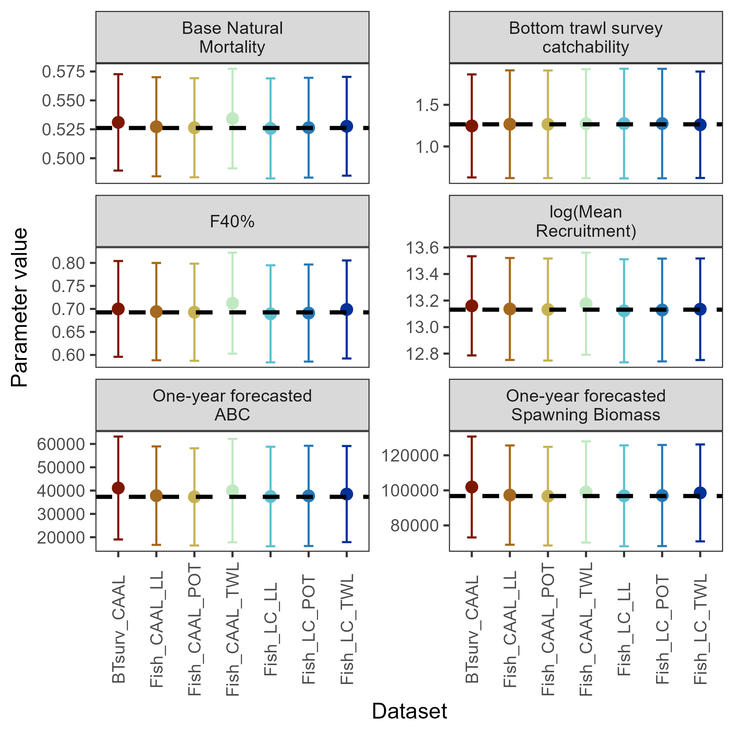

Figure 2.S4. Add-one-in analysis showing parameters and derived quantities as each data source were added to Model 24.0. CAAL denotes conditional age-at-length data, LC denotes length composition data, and Indx denotes index data from the bottom trawl survey (BTsurv), longline survey (LLsurv) and fisheries (denoted with gear type). The horizontal dashed line denotes the Model 24.0 estimate with only catch data updated.

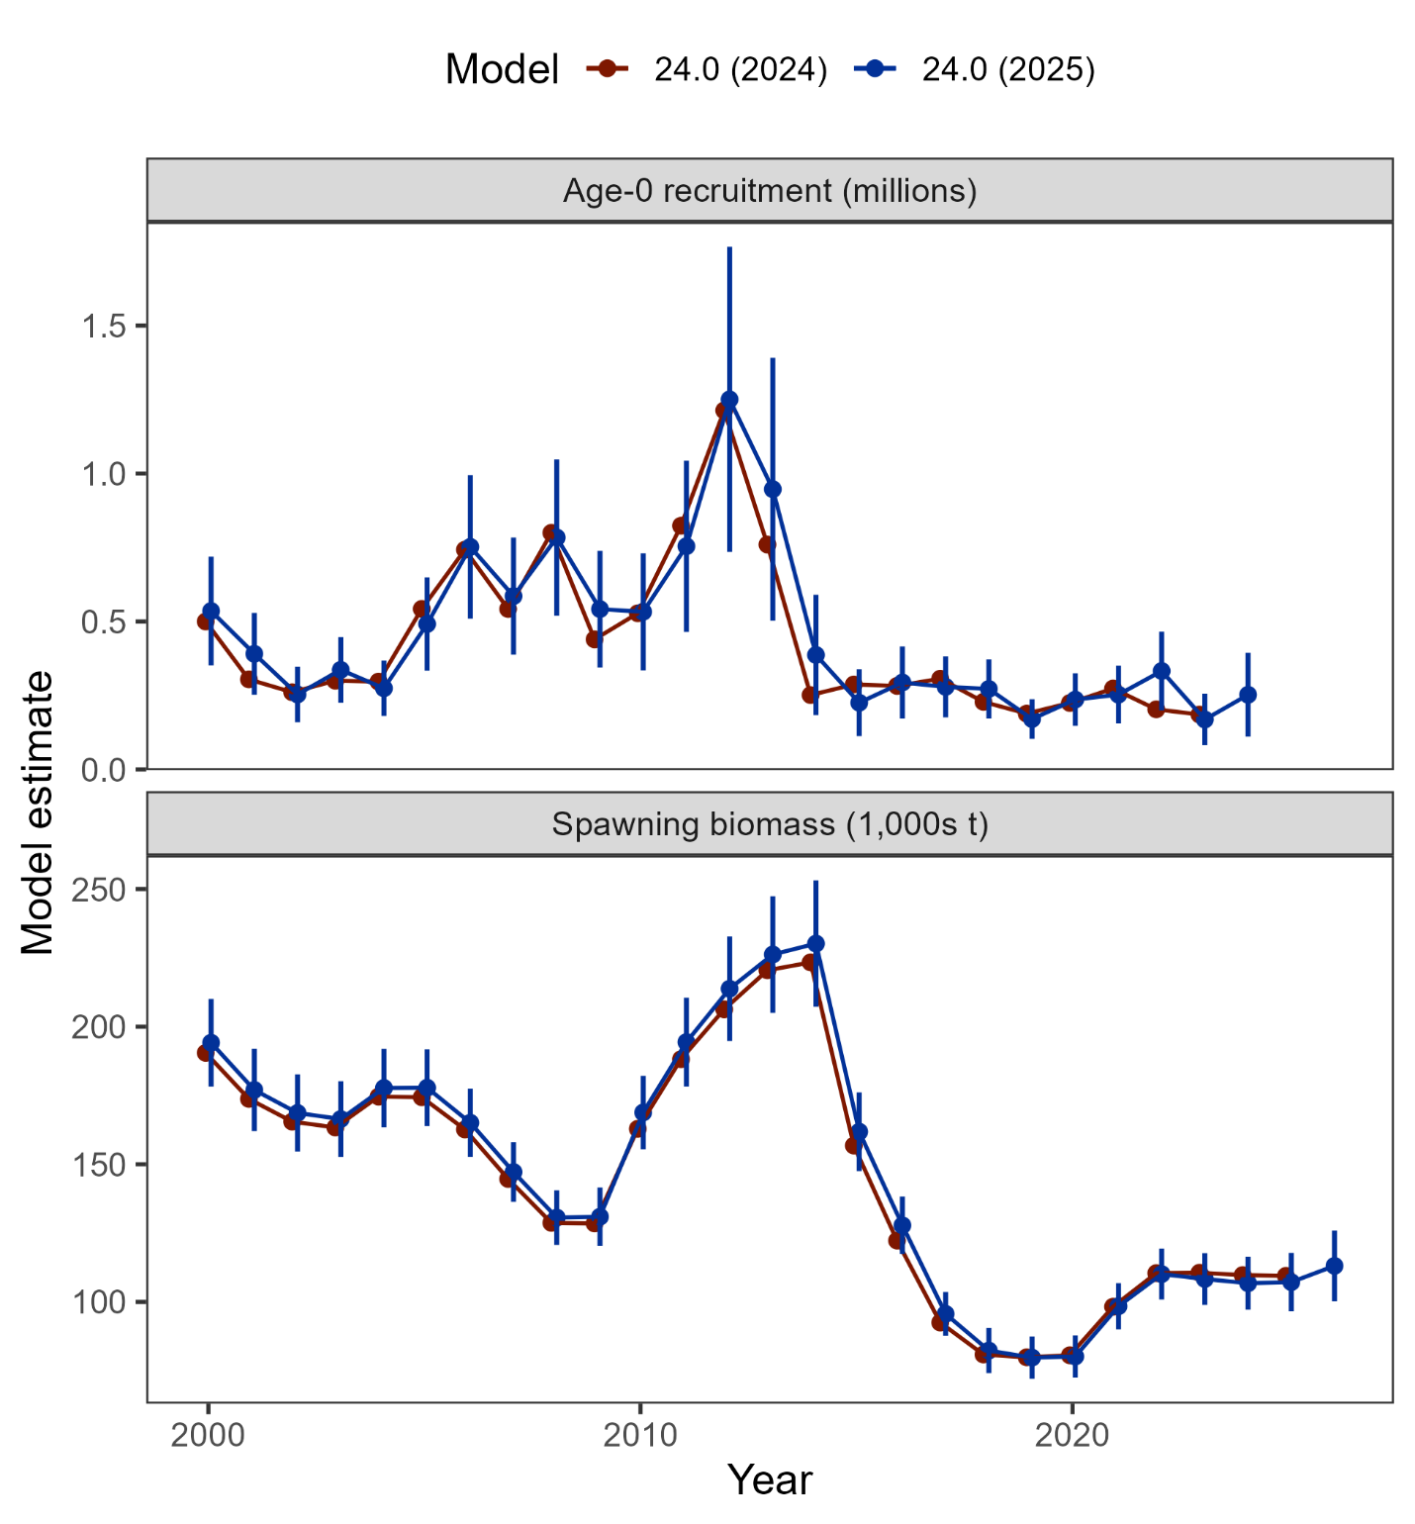

Figure 2.S5. Comparison of post-2000 recruitment and spawning biomass estimated from Model 24.0 as applied in 2024 and with updated data in 2025 (including 95% confidence intervals).

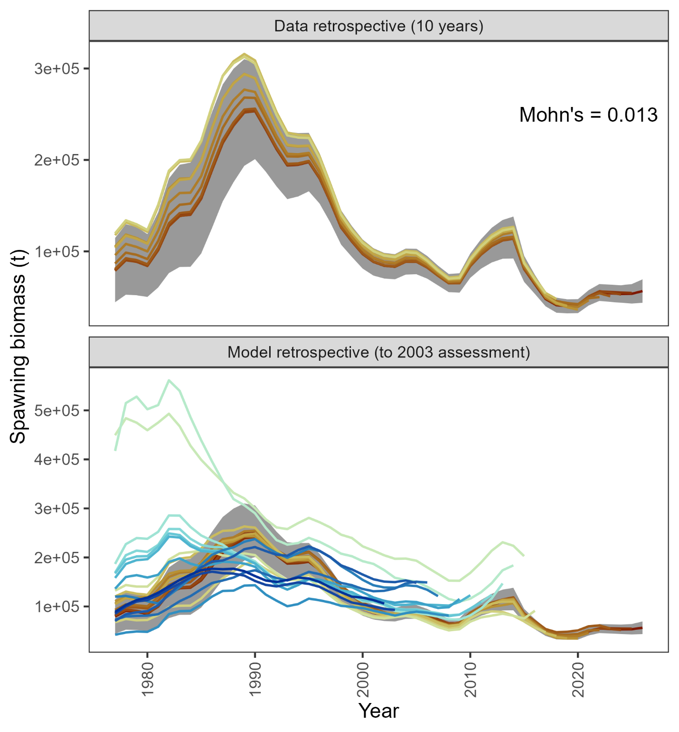

Figure 2.S6. Retrospective analysis of spawning biomass upon removing data from Model 24.0 as applied in 2026 (top panel) and in comparison to previously accepted models (bottom panel). The shaded region is the 95% confidence intervals from Model 24.0.

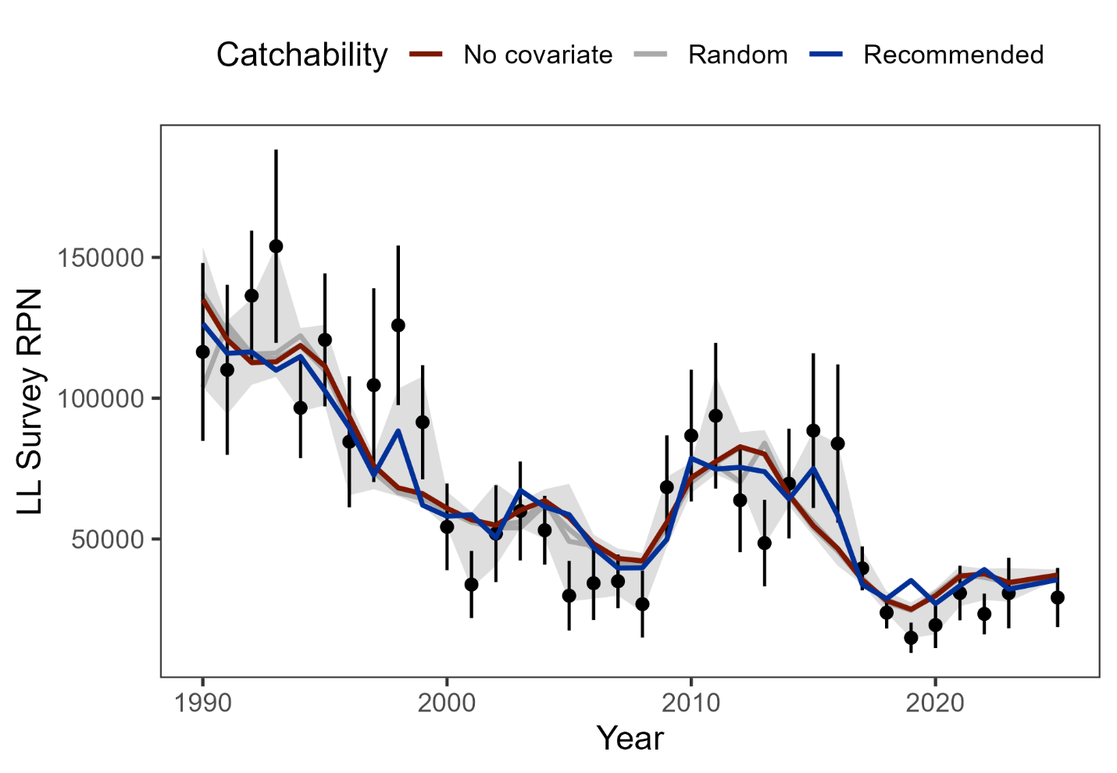

Figure 2.S7. AFSC longline survey catchability environmental link analysis where ‘No covariate’ is Model 24.0 with the environmental link parameter turned off, ‘Random’ is when white-noise was generated and used in place of the CFSR index (two random draws are shown in grey as an example, and the range of model fits with random white noise is shown in the grey shaded region), and ‘Recommended’ is Model 24.0 with updated data through 2025 using the CFSR index as a link to survey catchability. Based on the Akaike Information Criterion model comparison, Model 24.0 with the environmental link applied to the AFSC longline survey catchability remains the preferred model.

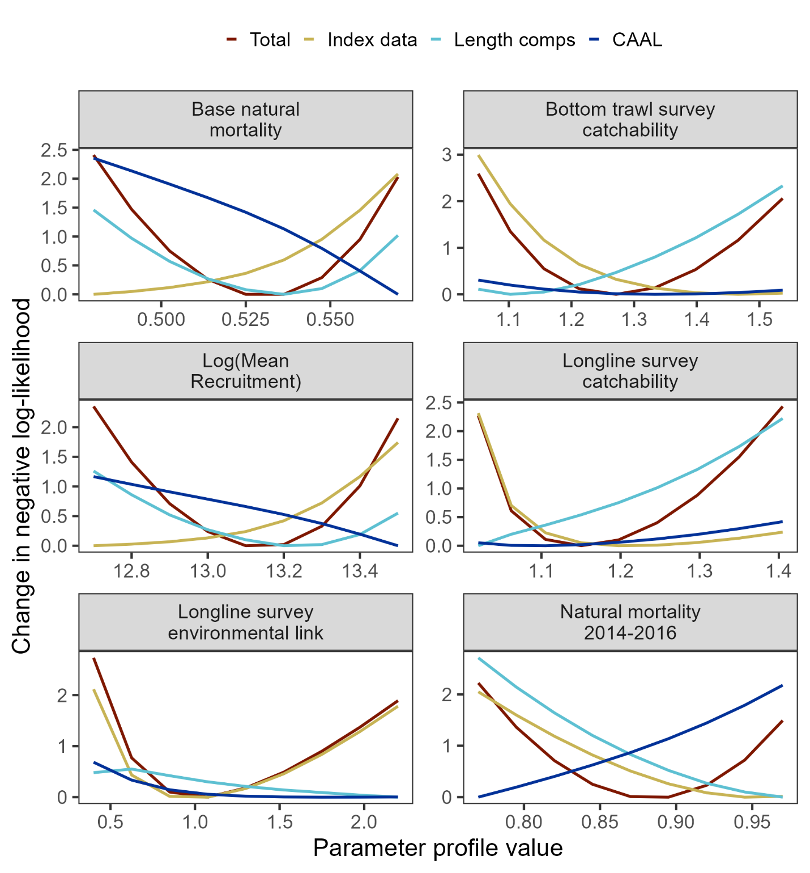

Figure 2.S8. Negative log-likelihood profiles for key parameters estimates in Model 24.0 updated with 2026 data.

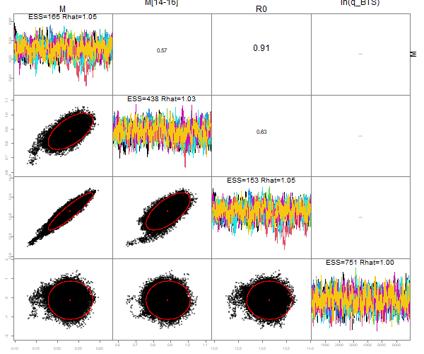

Figure 2.S9. MCMC pairs plot of key model parameters from Model 24.0 updated with 2026 data, with diagnostics shown in the diagonal and parameter correlations shown in the top right.

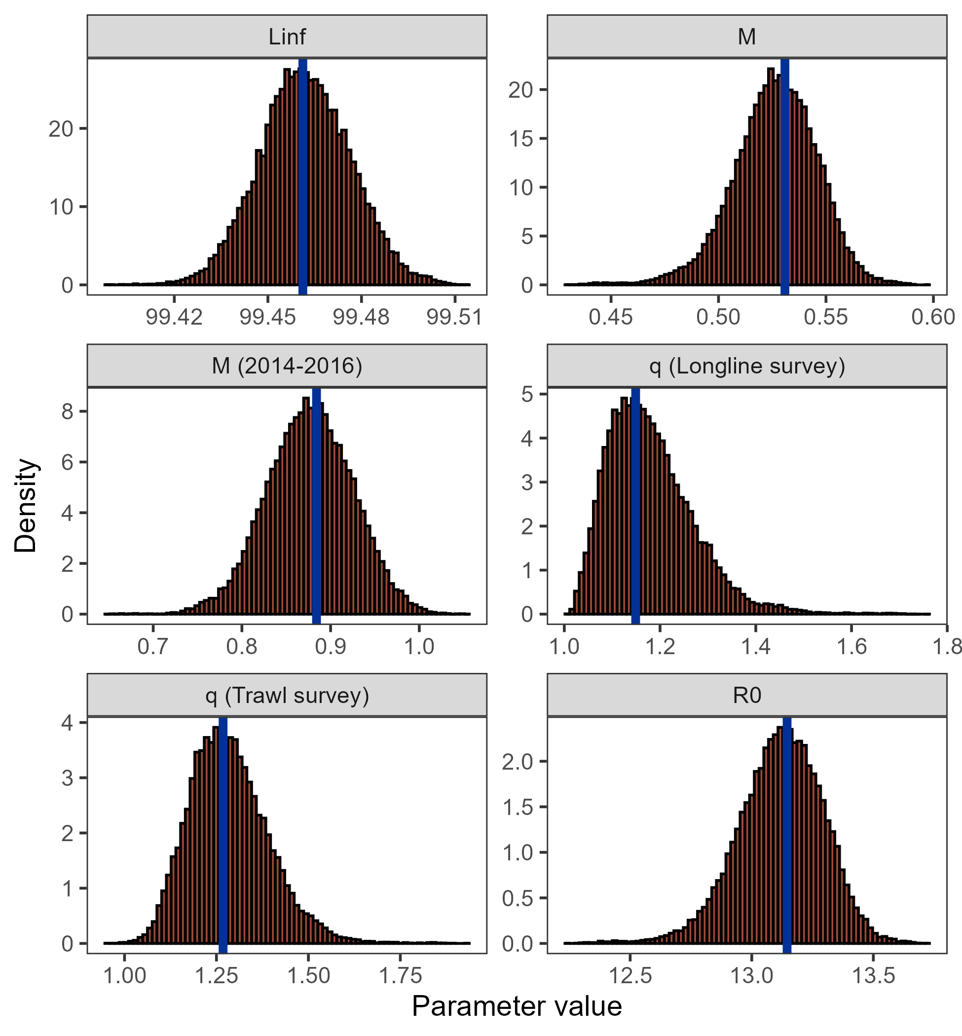
Figure 2.S10. Histograms of MCMC draws for key parameters from Model 24.0 updated with 2026 data compared to MLE estimate (vertical line).

